Prestools install guide
Brent Dacus 2019

I am a Visual guy so I added some screen shots to MusicMans guide. I hope this helps others.
This guide is an open document. Parts of it may need correcting or more verbiage. Feel free to add to it.

Prestools Suite is a script – not a module. So installing it as a module will not work.

BACKUP your FILEs and DB before you do this. I warned you… Practice in your Test Store first…. Wait what you don’t have a Test store…HUMM. You backed up right?

Link to the tools. https://www.prestools.com/Prestools_Suite.zip

- Download to your Computer:
  - Should find
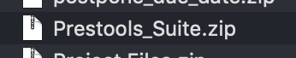
Then unzip it
Should be
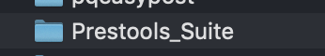
  - I would rename it to whatever it want it called. That way once you transfer it to your admin folder it will be correct.
From the manual: You are free to choose the name of this directory and as a matter of safety a creative name is encouraged.
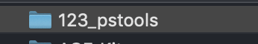

- Next for ease of use we will fix up the Config file now.
  - So still on your computer open the newly renamed (123_prestools) folder inside look for “settings1.php”
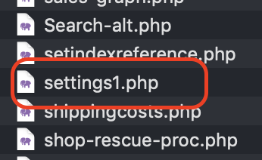
  - Open it in a text editor. NOT MS Word (I use Visual Studio Code) but notepad, sublime, atom and others are fine.
Look for
From the manual: The default login data are username “demo@demo.com” and password “opensecret”. However, you are strongly advised to change these data in the file settings1.php.
Change the $username entry to something like your email like: shopownerrule@mycoolshop.com OR sh0pOner2kul (doesn’t have to be email)
Then set $password to your favorite one…. 12345678 or abcdefg123. Something strong.
Looks like this
Save and close the file.

- Now fire up your FTP client. FileZilla, Transmit, cyberduck
  - My screenshot are from FileZilla
On the local side
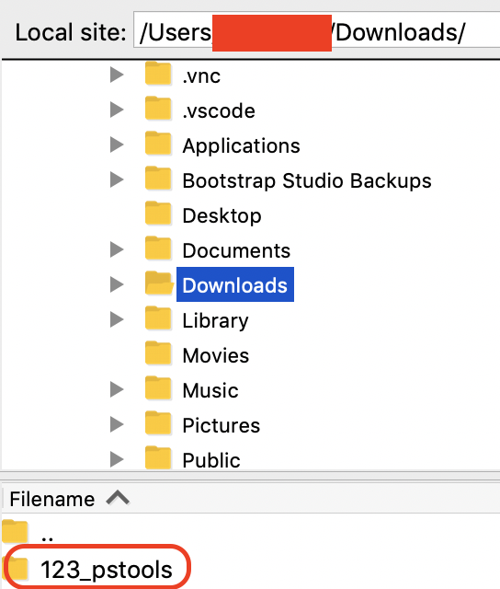

Remote side
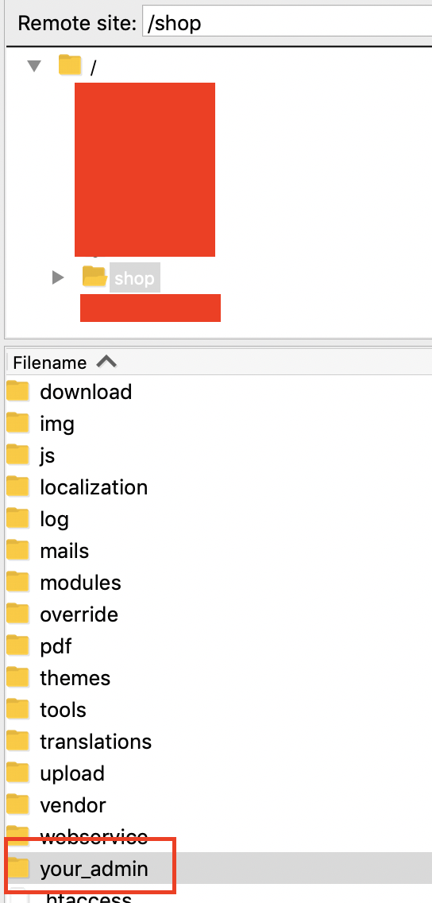
Drag or transfer the 123_pstools AKA the folder you named in step 1. B. into your admin folder here its your_admin.

From the manual: Instead you should copy the files into a directory under your admin directory. This location was chosen because Prestashop protects this location from scanning by search engines. Just like the name of your admin directory you should keep this name secret for security reasons. Once you have copy the files you can start working.

Should look like this...
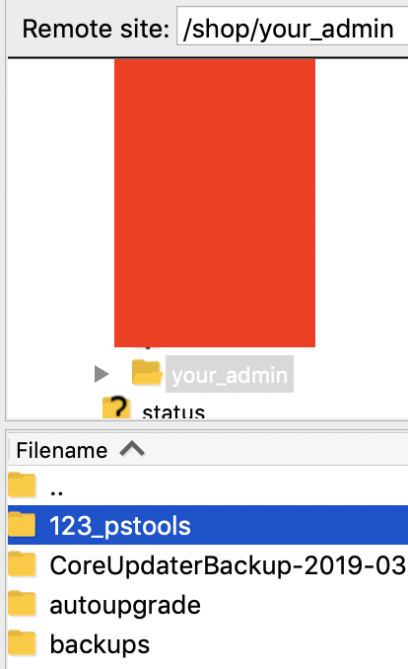

Once it finishes transferring. Inside 123_pstools should be similar
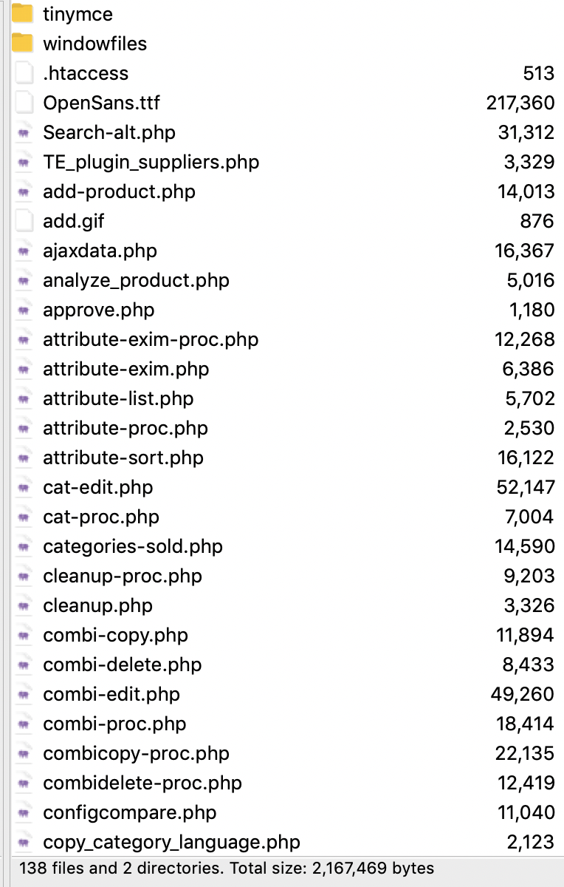
Whew let see how we did…

  - Now go to your web browser. Chrome firefox… yadayada
https://shop.yourkulshop.com/your_admin/123_pstools/login1.php
Whatever your chose names are for admin and pstools folder name with /login1.php on the end.
Login
If you got it all correct
You should see. A white screen with a login prompt…

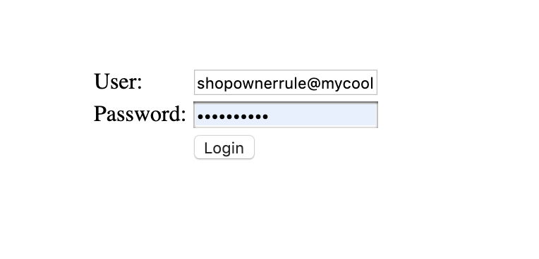
Type in whatever you chose for $username and $password

If you were successful. You should see across the top. If you made it here it is all installed. Congrats. You can stop here or do optional security stuff..
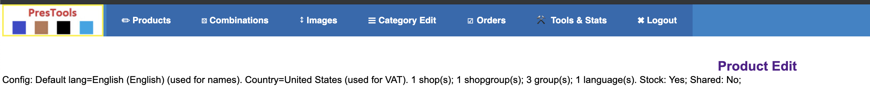

OPTIONAL

- Password encryption
From the Manual: There is an option to encrypt the password that is explained in the that file.

  - The file is md5.php
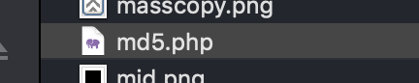

  - Go to your browser and type. Example:
https://shop.yourkulshop.com/your_admin/123_pstools/md5.php

You should see this box.
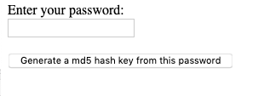
Type in your password and click generate.

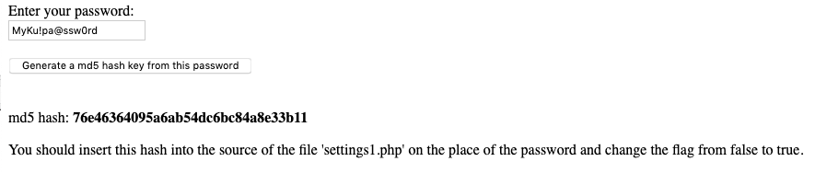
So go back to the settings1.php file on your Computer
Make the changes and save.

Now reupload that one file back like in step 3. a. into the 123_prestools folder.

If you did it correct you can still login with your password.

- IP address:
From the manual: For further security you can specify there from which ip addresses the script can be used. The program shows what ip address currently is being used so you don't need to search for it.
  - Ok this for whatever IP address you want to access pstools from like the Computer you are on at home or office.
The trick is it needs to be your Internet IP of your computer or the one you want to use it at. You can get it from the login1.php page in prestools OR Google knows: Go to search and type. “my ip”
You should get Your IP address is XXX.YYY.ZZZ.QQQ

  - Now open the settings1.php file on your Computer…. I know not this again.
Open it and add in whatever ip address you need. Keep in mind you won’t be able to access pstools from OTHER ip address’. Friends house = NO My house = NO The IP you added to the file Bingo..
Looks like.
Now reupload that one file back like in step 3. a. into the 123_prestools folder.

If you did it correct you can still login with your password.

Hope this helps. Brent

